**System Architecture:**

As far as system architecture goes, Project Themis most closely relates to the Observer Pattern. Our clients are constantly ‘observing’ the server to check for changes in the database that tell the clients when something is happening such as an account being created or a game being started, and then updating the clients with the new information. The server is the subject, because it is being watched for changes while the observers are any and all the clients that are currently connected.

**Class Diagram:**

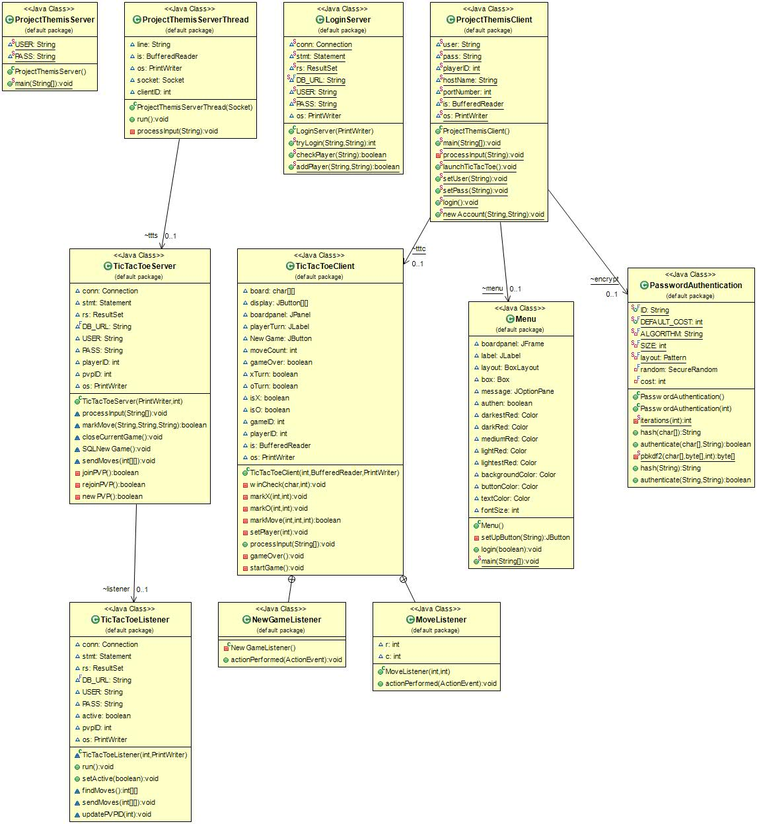Main Server Class Diagram with Menu, TicTacToe, and Login included

**User Interface Design:**

Interfaces for our menu, Othello, Connect Four, and Tic Tac Toe

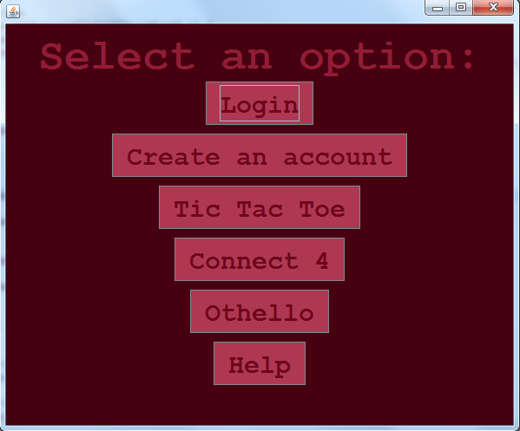

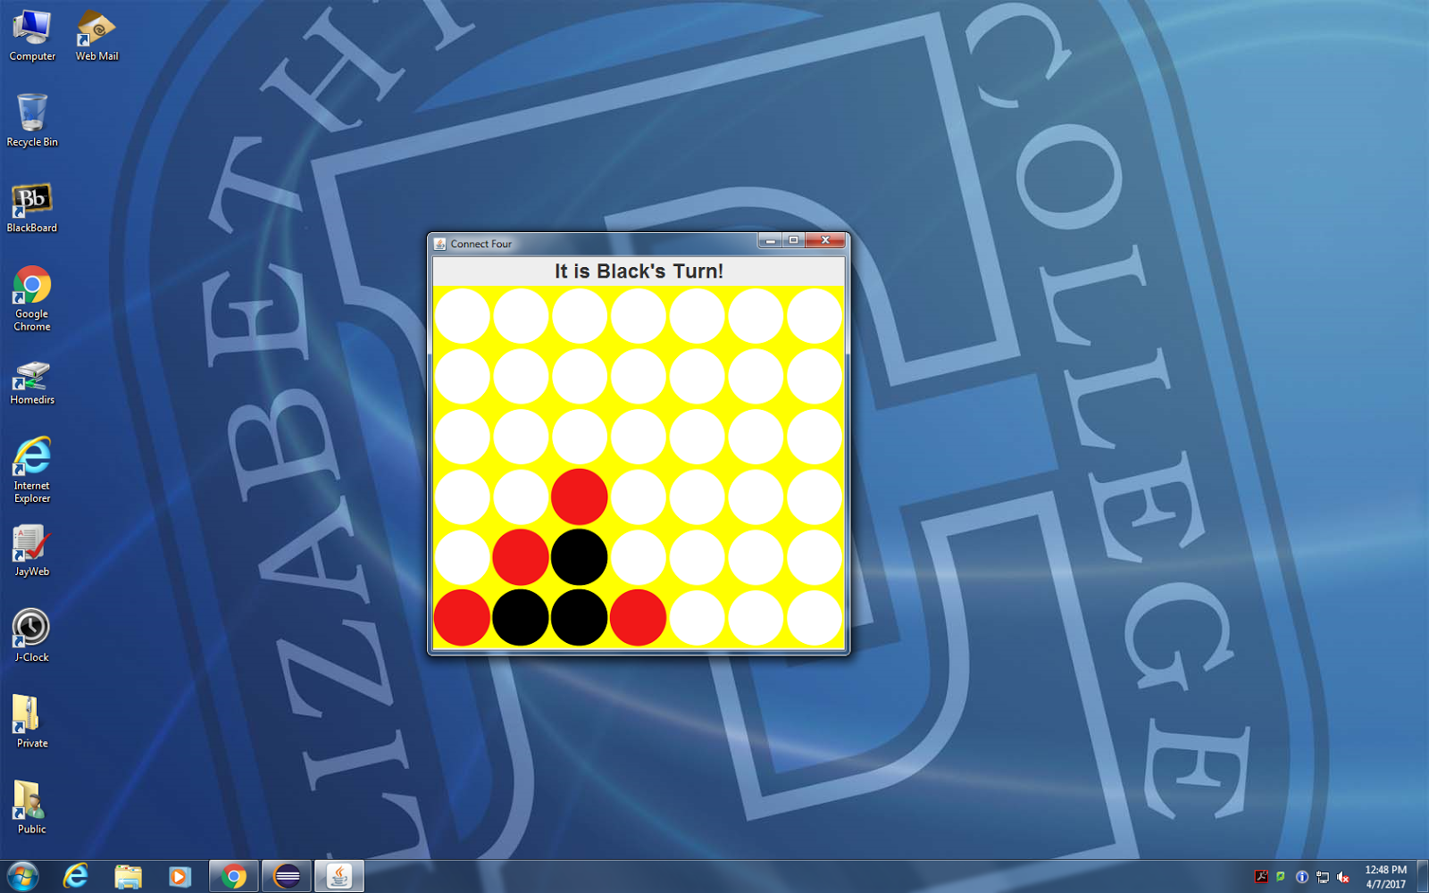

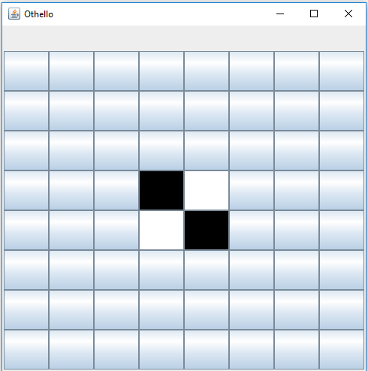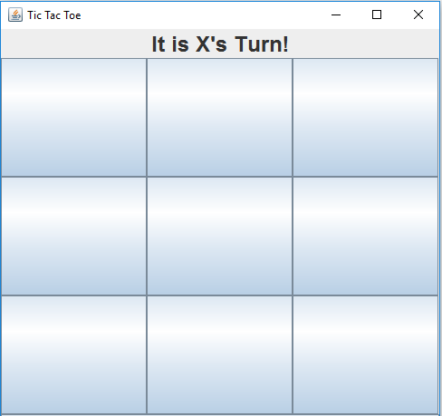

**Table of Work Accomplished:**

|  |  |  |  |  |  |
| --- | --- | --- | --- | --- | --- |
| Name: | Documentation | Game Work | Server Code | Server Hardware | SQL |
| Alpha | Customer and System Specifications, presentation & started Latex documentation |  |  | Installed correct Ubuntu software with Java & MySQL |  |
| Alex | Edited Latex documentation, use-case diagram | Connect 4 (stand-alone functioning) | Connect 4 to server communication (in progress) |  |  |
| Byron |  | Connect 4 (stand-alone functioning) | Designment menu for our server & worked on connect 4 to server communication (in progress) |  |  |
| Devin | Class diagram for demo version of server | Tic Tac Toe (working with server) | Set up Tic Tac Toe server, framework of server-client communication | Setup MySQL, physical server location, NoIP | Set up database to store game info |
| Matt |  | Othello (in progress) | Set up log-in system for server |  |  |